Rosemount Analyzer 1056/1057 Replacement Project: Conductivity probe

The conductivity probe currently employed by TRITON is the Rosemount Endurance 400-12/400VP-12. The VP model offers a Variopol quick disconnect connector, but otherwise both models are equivalent. The probe is also equipped with a PT1000 resistor temperature detector (RTD). The Rosemount Analyzer 1056 and 1057 are commercial electronic instruments designed to be used with the conductivity probe to automatically measure conductivity. The difference between them is simply the number of probe slots available. A conductivity measurement consists of an AC resistance measurement of a sample, and the conversion from resistance to conductivity with a temperature correction. The purpose of this project is to bypass the Rosemount Analyzer, and to design an in-house method to read solution conductivity from the probe.

# Conductivity Theory

The conductivity of a solution is a measure of its ability to conduct electricity. It can depend on ion concentration, ion mobility, and temperature. It is the inverse of the electrical resistivity of the solution. A conductivity measurement involves measuring the electrical resistance between electrodes submerged in the sample solution and from that calculating the conductivity. A temperature correction factor must also be included. The two common methods for conductivity measurement are shown below. As the Endurance 400 is a two electrode probe, we will only concern ourselves with that method.

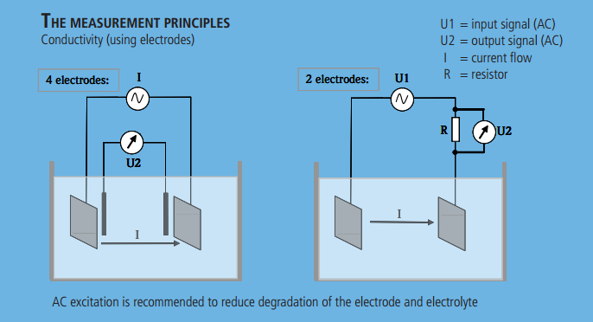

Figure Methods of conductivity measurement. Retrieved from Innovate Sensor Technology AG: http://www.ist-ag.com/eh/ist-ag/resource.nsf/imgref/Download_BC_E1.0.pdf/$FILE/BC_E1.0.pdf

The fundamental measurement being made is a resistance measurement. This can be done in several ways, but we must avoid any DC methods. This is because a static voltage applied across the probe electrodes will cause ion buildup and polarization of the probes, which are nonlinear effects that will give incorrect measurements. Thus, we will apply an AC resistance measurement method. In addition, any AC signals applied across the probe electrodes must oscillate around 0V (the solution ground), so that the ion drift direction alternates. This prevents ions from building up on only one side of the probe.

**Resistance**

The resistance *R* [Ohms, Ω] of a solution (or any material) is given by Ohm’s law

$$R=\frac{V}{I}$$

where *V* [Volts, V] is the voltage applied across the material

*I* [Amperes, A] is the resultant current

The resistance of any device is a function of the device’s size and its material resistivity.

**Resistivity**

Resistivity is a material property. It is related to resistance by

$$ρ=R\frac{A}{l}$$

where *ρ* [Ω∙m] is the resistivity

*l* [m]is the length of the device (distance between electrodes)

*A* [m2] is the cross sectional area of the device (area of electrodes)

**Conductance**

Conductance *G* [Siemens, S] and resistance are reciprocals of each other, ie.

$$G= \frac{1}{R}$$

**Conductivity**

Similarly, conductivity *σ* [S∙m-1] and resistivity are reciprocals, ie.

$$σ= \frac{1}{ρ}$$

**Cell constant**

All conductivity probes come with a cell constant k [m-1]. For parallel plate electrodes,

$$k= \frac{l}{A}$$

The Endurance 400 has cylindrical electrodes, so the calculation of the cell constant is more involved. For our purposes, however, we only need to know the value of *k*, which is given by the manufacturer.

Combining the above, we arrive at a useful expression for conductivity:

$$σ= \frac{k}{R}$$

**Temperature correction**

Since solution conductivity has temperature dependence, it is converted by convention to conductivity at 25°C. Hence we modify the conductivity based on the fact that the conductivity of an electrolyte changes by the same percentage for every °C change in temperature. This percentage, *α*, varies for different electrolytes, but is commonly taken to be 2%. As a result, we have our final expression for conductivity:

$σ_{25}= \frac{k}{R}∙\frac{1}{1+ α(T-25)}$ (1)

where T is the solution’s temperature in °C.

# Measuring Resistance

At our disposal is a National Instruments (NI) USB-6210 data acquisition (DAQ) module, which is capable of reading voltages in the range -10 to 10 on 8 channels. It’s essentially a voltmeter. To perform an AC resistance measurement, we need to apply an AC signal across the electrodes and measure the resultant current. A shunt resistor can be used in series with the probe electrodes so that reading the voltage across the shunt resistor will give us the current. Thus we can determine the solution resistance using two voltage input channels on the DAQ.

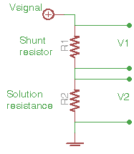Figure 2 depicts the circuit for the resistance measurement. The resistance of the solution between the two probe electrodes is directly related to its conductivity. Electronically, the probe submerged in the sample solution can simply be thought of as a resistor, so it is drawn as R2. The current passing through either resistor is the same, so Ohm’s law gives:

Figure A resistance measurement using 2 DAQ channels

(2)

R2 is the solution resistance, which is written as R in equation (1). Note that this is independent of what Vsignal we drive the circuit with. Our task now is to determine what AC signal to use, and then to build the appropriate signal generator.

Before designing our AC circuit, it is useful to learn what signal the Rosemount Analyzer applies and measures. We can use this information to guide us when designing the measurement circuit.

The Rosemount analyzer was connected to the conductivity probe. This connection was split to connect the probe electrodes to the DAQ in order to measure their voltages. Shown below is the measurement for tap water. Red and blue are the probe electrode voltages referenced to ground, and green shows the differential voltage across the electrodes. Here there is a discrepancy in the waveforms, since the green trace does not appear to be the difference between the red and blue as shown. This was resolved once we measured the ground of the Rosemount analyzer board and found it to have a DC component which exactly canceled the shape of the blue waveform.

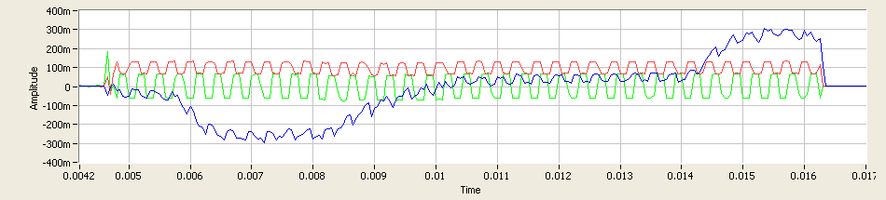

This measurement was performed on air and some salt solutions, and the results are summarized in the table below.

|  |  |  |  |
| --- | --- | --- | --- |
| Solution | Conductivity Reading (µS/cm) | Signal peak-to-peak voltage (mV) | Signal frequency (Hz) |
| Air | - | 200 | 250 |
| Tap water | 339 | 125 | 3.2k |
| Salt solution 3 | 6600 | 70 | 2.4k |
| Salt solution 2 | 16250 | 27 | 2.4k |
| Salt solution 1 | 31500 | 18 | 2.4k |

From this we can conclude:

1. The theory works. Conductivity is inversely proportional to voltage and therefore resistance.
2. We can apply a square wave signal across the probe electrodes to do the conductivity measurement. This has the advantage of being easier for signal processing than a sine wave, as the peak values are well defined and easier to detect.
3. The frequency of the wave should be on the order of 2kHz. The probe electrodes are physically configured like a parallel plate capacitor, so they behave like a high pass filter. Knowing the analyzer’s signal, we can safely assume that 2kHz does not get attenuated when passing through the probe.

To produce a square wave, we use an op amp in an astable multivibrator configuration, set to generate a signal at 2kHz. The peak voltages match the supply voltages, for which we use ±5V. The circuit is described at <http://hyperphysics.phy-astr.gsu.edu/hbase/electronic/square.html> and the resistances were selected using the equations given. The final circuit is shown in Figure 3.

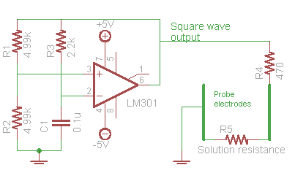

Figure Conductivity circuit

The supply voltages were measured to be +5.23V and -5.06V. The output of the square wave circuit, with the shunt resistor and probe disconnected, was measured with the DAQ and is shown in Figure 4. Exactly 8 periods of the square waveform span 0.004s, which gives a frequency of 2kHz as expected. The peak voltages do not match the supply voltages, but as explained previously, this will not affect our resistance measurement. Finally, the voltage oscillates about 0V as required. Thus this signal satisfies our requirements and we can use it to drive the resistance measurement circuit.

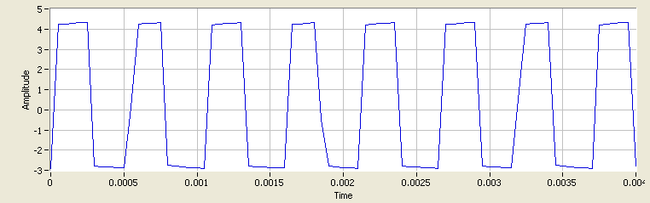

Figure Square wave generator output

The final circuit was assembled and the conductivity probe was submerged in a 500µS/cm conductivity standard solution. Readings for V1 and V2 are shown in Figure 5. The shunt resistor used is 470Ω. MATLAB code was written to acquire the two signals, detect the average peak to peak voltages, and calculate conductivity according to equations (1) and (2). The details of the program are omitted in this report. The cell constant used was 0.0962, as written on the label of the probe. The solution temperature was measured with a mercury thermometer to be 23.5°C. We obtain a solution resistance of 202.7Ω, and a conductivity of 489.3µS/cm. This is a 2% difference from the expected value of 500µS/cm.

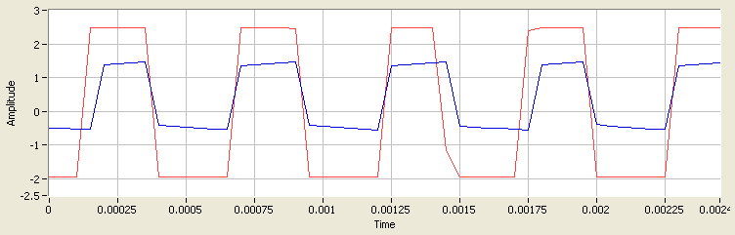

Figure Readings of V1 (shunt resistor, red) and V2 (probe, blue)